College: Kenya Medical Training
Campus: Siaya

Department: Nursing

Topic: Kohlberg Theory

Comprehensive assignment in partial fulfillment for requirements of the course Psychology.

By Group 4;

Fredrick Ochieng D/NURS/18029/4374
Leviter Onsongo D/ NURS/18029/4718
Pauline Lukhale D/NURS/18029/983
Robert Opaah D/NURS/18029/953
Stacy Atieno. D/NURS/18029/971
Nelly Gacheri D/NURS/18029/973
Patricia Odhiambo D/NURS/18029/165
Mercy Matee D/NURS/18029/960
Branson kithome D/NURS/18029/970
Lecturer: Phelix Ogada
24/01/2018

Development theory according to Kohlberg Lawrence
Lawrence Kohlberg was an American psychologist who existed between 1927 to 1987. He is best known for the theory of moral development. He decided to study moral development to extend Jean Piaget's account of children's moral development from 25 years earlier. He created a new field in psychology in an empirical study using 6 criteria as as citations and recognition.
He said that the development is achieved through level and stages.
He died in Jan,1987

Level 1: Preconventional Morality
Stage 0: Pre moral(before moral)
Signs
1.Not immoral but amoral; lacking ability to discern right or wrong
2. No sense of obligation/Morality; No compression of effects of action. Last between 2-3years of age.
3. Pleasure pain determine behavior: Usually found in a baby and/or toddlers,during this stage babies do not have any idea whether if it is hurtful on another but more concentrated on her/his well being
4. Take what is pleasant avoid unpleasant
5. A person is guided by what he/ she wants to do even hurting others for excitement
He said that moral development can be acquired through levels and stag
Consists of two stages
Stage1: Punishment-obedience Orientation
This is the use of punishment si that a person refrains from doing the action and continue to obey the laws

Stage 2: Instrumental Relativist Orientation
In this stage Morality of the action is judged based on how it satisfies the individual needs of the doer. eg a person steals money from another person to buy food for his hungry children

Level 2: Conventional Morality
Second level and consist of stages 3 and 4
Stage 3: Good boy-Nice girl Orientation
Here a person judges an action based in social expectations and societal roles before him.
Also known as the "interpersonal relationships" phase.eg a child giving her lunch to a street peasant because she thinks doing so means being nice

Stage 4: Law and order Orientation
This includes respecting the authorities and following the rules as well as doing a person's duty. The society is the mai consideration of a person at this stage.eg a policeman refuses the money offered to him under the table and arrests the offender because he believes this is his duty as an officer of peace and order.

Level 3: Post conventional Morality
Includes stage 5 and 6 and is concerned with the universal principles that relates to the action done
Stage 5: Social Contract
Here the person looks at various opinions and values of different people before coming with a decision on the Morality of the action.
Stage 6: Universal ethical principles Orientation
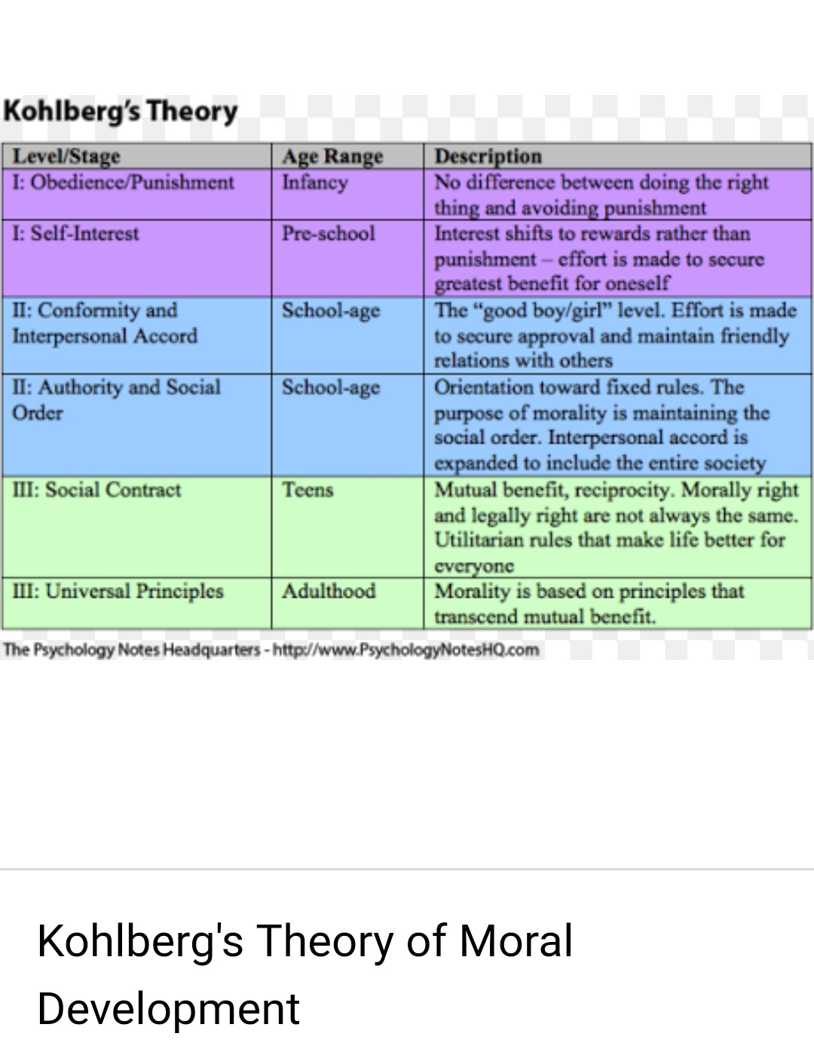
The final stage of moral reasoning. It is when a person considers universally accepted ethical pprinciple

